**Self-Assessment Questions (SAQs)**

**Activity Three Electric Current and Circuit Theorem**

**1**. The figure below shows a battery of 6.5 V and negligible internal resistance connected to ten resistors. Calculate the p.d. V across the $6Ω$ resistor and the current passing through the $8Ω$ resistor.

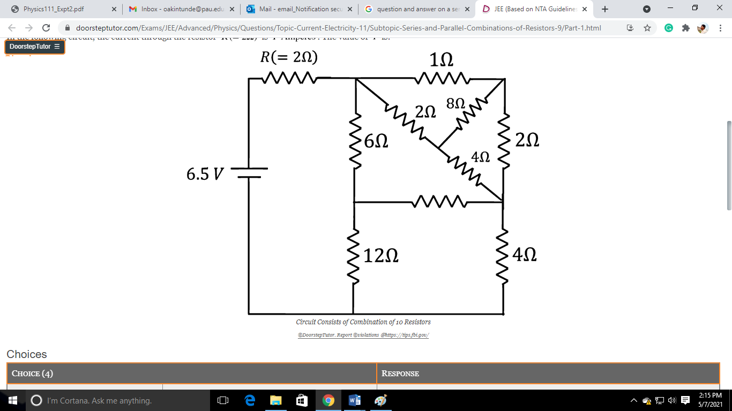

**2.** A battery of Emf. 8 V and internal resistance r is connected to a $10Ω$ resistor. Given that the terminal p.d. across the resistor is 5 V, calculate the value of the internal resistance of the battery.

**3**. A 4.80m length 2.0-mm-diameter wire carries a 750mA DC current when 22.0 mV is applied to its ends. If the drift velocity is $1.7×{10}^{-5}ms^{-1}$ determine (a) the resistance R of the wire, (b) the resistivity $ρ$ and (c) the number n of free electrons per unit volume.

**4.** What is the magnitude of the electric field across an axon membrane $1.0×{10}^{-8}m$ thick if the resting potential is $70mV$?

**4.5**. A neuron is stimulated with an electric pulse. If the density of free electron is $8×{10}^{28} m^{-2}$ and it takes $67μs$ to transmit the information to other nerve cells, muscle, or gland cells. (i) What is conductivity of the neuron. (ii) at what speed will the information transmit if the Electric field intensity passed across is $75×{10}^{-5}N/C$.

**6.** Two large horizontal, parallel metal plates are 2.0 cm apart in vacuum and the upper is maintained at a positive potential relative to the lower so that the field strength between them is $2.5×{10}^{5} V m^{-1}.$ (i) What is the p.d between the plates? (ii) If an electron of charge $1.6×{10}^{-19} C$ and mass $9.1×{10}^{-31} kg$ is liberated from rest at the lower plate, what is its speed on reaching the upper plate? (iii)A cell with internal resistance supplies a current. Explain why the terminal potential difference (p.d.) is less than the electromotive force (e.m.f.) of the cell.

**7.** A battery X of e.m.f. of 6 V and internal resistance $2Ω$ is connected in series with a batter;-

Y of e.m.f. 4 V and internal resistance $8Ω$ so that the two e.m.f act to oppose each other, calculate the terminal p.d. of X and Y.

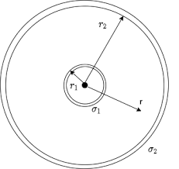**8.**  A small immersion heater can be used in a car to heat a cup of water for coffee or tea. If the heater can heat 120 mL of water from 25°C to 95°C in 8.0 min, (a) approximately how much current does it draw from the car’s 12V battery, and (b) what is its resistance? Assume the manufacturer’s claim of 85% efficiency.

**9.** Determine the electric field E, the current I, the current density J, and the resistance R for the case of two concentric spherical shells of radiuses a and b ( 𝑎 < 𝑏) whose interior is filled with a conductive material of resistivity $ρ_{o}$. It is known that the current flows from the inner to the outer sphere and that the electrical potential between these spheres is V.

**10.** A straight cylindrical wire lying along the x axis has a length of 0.500 m and a diameter of 0.200 mm. It is made of a material that obeys Ohm’s law with a resistivity of $ρ=4×{10}^{-8}Ωm$. Assume that a potential of 4.0 V is maintained at $x=0$, and that $V= 0$ at $x= 0.50 m$. Find

(a) the electric field E in the wire, (b) the resistance of the wire, (c) the electric current in the wire, and (d) the current density J in the wire. (e) Show that $E=ρ J.$

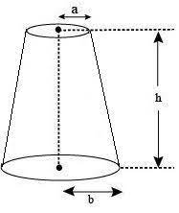

**11.** A material of resistivity r is formed into the shape of a truncated cone of height h as shown below. The bottom end has radius b, and the top end has radius a. Assume the current is distributed uniformly over any circular cross section of the cone so that the current density does not depend on radial position. (The current density does vary with position along the axis of the cone.) Show that the resistance between the two ends is

$$R=\frac{ρ}{π}\left(\frac{h}{ab}\right)$$

**12.** The resistance of a conductor at ${20}^{o}C$ is $8.45Ω$ and at ${100}^{o}C$ is $7.35Ω$. Determine the temperature coefficient of resistance of the conductor. What will be the resistance of the conductor at $0^{o}C$

**13.** A copper wire 3.2 mm in diameter carries a 5.0A current. Determine the drift velocity of the free electrons. Assume that one electron per Cu atom is free to move (the others remain bound to the atom).

**14.** A generator supplies a current of 10 A to charge a storage battery which has an open-circuit voltage of 5.6 V. If the voltmeter connected across the generator reads 6.7 V, what is the internal resistance of the generator?

**15.** An aluminum wire with a diameter of 0.100 mm has a uniform electric field of 0.200 V/m imposed along its entire length. The temperature of the wire is 50.0°C. Assume one free electron per atom. (a) Determine the resistivity. (b) What is the current density in the wire? (c) What is the total current in the wire? (d) What is the drift speed of the conduction electrons? (e) What potential difference must exist between the ends of a 2.00m length of the wire to produce the stated electric field?